Kash Patel Explains How Trump Docs Were Declassified and Handled

https://www.clayandbuck.com/kash-patel-explains-how-trumps-documents-were-handled/
15 AUG 2022
CLAY: We’re joined now by Kash Patel. First of all, thank you for joining us, formerly with the Trump team in a variety of different roles, I think, over your tenure there. But we had you on in May when this declassification, classified document scandal I put in quotation marks really started to take off. And you walked us through the process by which many of these documents were being declassified.
So, let me just kind of give you a broad question to start with here. What do you know about the documents that were in Mar-a-Lago and their classified or declassified-related state? And what do you think about the FBI investigation so far as you’ve been able to hear about so far?
PATEL: Yeah, hey, it’s great to be with you, Clay, thanks so much for having me. And back then, you know, you guys were the one, if not only, people willing to cover what we thought was a massive national security story related to the archives. And what I can tell you is that this is how this works, and you guys know this. The president of the United States has universal declassification authority. If he says it or writes it anywhere about documents or sets of documents, they become immediately declassified.
Now, in October of 2020, the president wrote a statement that’s now publicly available that said, I declassify every Russiagate document and every Hillary Clinton email investigation document. That’s it. That’s what it takes. And then out as he was leaving the presidency in December or January, he issued further sweeping declassification orders at the White House over whole sets of documents.
So, those documents should have been immediately declassified. But what happened was they went to the politicians and now we know the National Archives representative has shown himself to be a political politician, said he referred the matter to the Department of Justice because he wanted Trump investigated because the GSA, not Trump, had mishandled the packaging of the documents. This same individual is the one who gave Hillary Clinton a pass and could have referred her email matter to the Department of Justice, but he said, oh, he didn’t feel it was necessary to do so at the time.
So what it shows is, the two tier system of justice, which is what the FBI is currently exemplifying, if you have anything to do or related to with Donald Trump, they will literally pull the levers of justice unequally and prosecute you based upon politics instead of the facts and the law. And tragically, the same FBI characters that were involved in Russiagate or Hunter Biden laptop or Hillary Clinton are the same counterintel guys now running this, quote, unquote, national security investigation against President Trump.
BUCK: Kash, it’s Buck, man. Thanks for being with us. I remember we had you on, I feel like, what, six months ago or something like that now, in the early days of this because that was when the dispute — you were talking about this dispute where they were bringing some legal action in the courts about what Trump had taken out of Mar-a-Lago. And now here we are, the basis for this crazy raid.
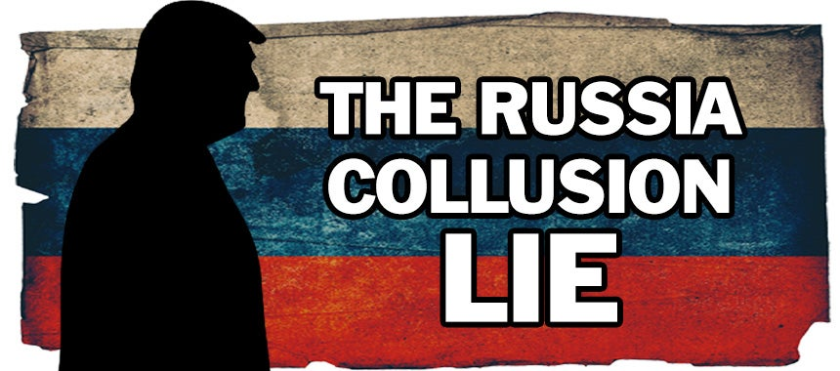Is this all going to turn on the claim, meaning, is the fight really going to be met here, the center of the battle going to be whether the president does have this unilateral declassification authority? Because, you know, I’m seeing, for example, the New York Times reporting, oh, national security experts are laughing at this notion the president can declassify. I remember when I was in the CIA they’re like, you tell the president anything he wants to know ’cause he can know literally anything in the government, he’s the top authority, and if he wants to go out on a press conference and talk about it, he can. So what has changed?
PATEL: Nothing. You’re absolutely right. And it’s been reported now recently that every president since Clinton and Bush has had standing orders that whenever documents leave the Oval Office and go to the residence at night ’cause he’s gotta go with work, they are automatically declassified. So there is a further level of declassification that occurs there automatically on top of when the president says it. And any national security former officials saying, “That’s not how it works,” that’s not how it works for the 99% of the other government employees because there’s a process in place so that classified information isn’t disposed or displayed improperly. But there’s a reason he’s the commander-in-chief. He’s the head of the United States government. And the Constitution gives him the power to declassify and classify as he sees fit. That’s the whole point.
CLAY: Kash, Buck and I were talking about this. Why do you think Trump had some of the documents that he did down at Mar-a-Lago? Do you think — and one of our theories is that he may have kept some of these documents because he wants them to be public and they aren’t being released publicly yet. What do you know about those documents? Why do you think he might have them?
PATEL: Well, I’ve never seen them or handled them, but I can tell you this. Barack Obama has 30 million documents at his house in Chicago. He has not released a single one, not one. He has cited the Presidential Records Act, ironically enough, to prevent the disclosure of any of the documents he took with him. Same for Bush. Same for Clinton. So, again, this two-tier system of justice, now everybody’s interested in 12 boxes of documents but not how every other president before President Trump was treated.
I don’t know what was in them, but I can tell you what happened before which is what we talked about at the top of the show. And it’s key to note that the GSA, the Government Service Administration, they’re the ones that packed up and moved these documents. It’s not like President Trump put him in his briefcase and hopped aboard Air Force One on January 20th and said, “Okay. I’ll see you guys later,” which is critical if you’re considering a case for improper use of classified information as we know from our friend James Comey during the Hillary Clinton investigation who set the standard when Hillary Clinton sent and received classified emails personally, she didn’t have the intent to violate the law. So if that’s the standard, then President Trump is as far away from it as you can possibly be.
BUCK: Speaking to Kash Patel, former DOD chief of staff under Trump and a deputy assistant to that White House. He’s also a Trump Media board member. Kash, now I’m asking you to do a little bit beyond the explanation and expertise asking into the, what do you see coming here or what’s between the lines on this one? Because, as I understand it, in those documents that have now been seized by the FBI, an FBI that we should not trust, there is a whole bunch of executive privilege covered documents that the deep state now has access to, perhaps even some privileged as legal communications between the president and his legal counsel documents they have access to. Do you think that this was more a fishing expedition, even, than anything else? How do you see that?
PATEL: Yeah, I think it’s a combination of both. And look. As a former national security prosecutor who worked in this national security division — and I remind people, there’s a difference between a criminal prosecution and a counterintelligence prosecution, which is supposedly what this is. It’s the latter ,that’s run out of the national security division of the DOJ. And I think what the world has seen is the shocking political overreach. And what this attorney general and this director of the FBI didn’t think would happen is, the boomerang would come back so quickly to hit them in the face. And so now we see the problems with this sort of government overreach.
You highlighted the biggest problem that no one’s talking about. Presidential privilege and executive privilege and attorney-client privilege, the DOJ’s now invading those usually off the limits documents because the target is Donald Trump. That is the ultimate two-tier system of justice. And that is a total violation of the law.
CLAY: Kash, you worked in the Trump White House. You know the guy. Do you think this raid has made him more or less likely to want to run for president again?
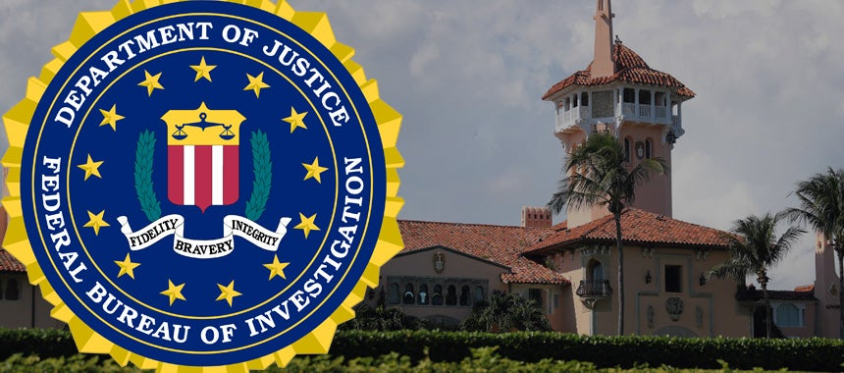PATEL: I mean, I think all these things make it more and more likely, and, you know, you guys also know him real well. You know, his thing is not necessarily just correcting his own name in the public. His thing is, this is wrong for America. The 2022 America, we have a president’s house being raided for the first time in history on, quote, unquote, a national security basis over documents that were in a basement in boxes under lock and key, after the Department of Just went there with Trump’s cooperation months before. None of this adds up. And I think this is going to make him want to run more because he wants to make sure it doesn’t happen to somebody else.
BUCK: One more for you, Kash. You were a federal prosecutor and specifically working on a lot of national security issues. Are they gonna indict President Trump?
PATEL: I don’t believe so. I don’t believe the facts — you know, if you look at the search warrant that’s now public, they said they have to sort of lay out which crimes they are alleging might be violated. One is the National Defense Information Act for classified information. The other is the destruction of government property that you’re not supposed to have, and the other one is the concealment of it.
Well, as far as we can tell from the public reporting, he hasn’t destroyed anything. And also he hasn’t — it’s not like he concealed anything. The GSA packed the boxes, moved them to the president’s home like they did for Obama and Clinton and Bush, and President Trump invited the DOJ in and said, whatever you guys need in the summer of — this past summer and said, what do you guys want to know? That doesn’t look like someone who’s concealing or hiding or destructing anything. If they do go out and indict him, I literally think that will be the end of the — I mean, if we’re not already there, it will be the end of the DOJ and the FBI.
BUCK: Kash Patel, always illuminating, sir. Thanks for being with us.
PATEL: Thanks, guys. Have a great day.

